**State of Connecticut Local Health Departments/Districts (LHDs)**

**Standard Operating Procedure TB Screening and Medical Evaluation for TB Class B Immigrants, Newcomers (Non-Class B Immigrants, non-refugees), Refugees, and Residents**

**Purpose**: The purpose is to ensure that people who have risk factors, signs, or symptoms of tuberculosis (TB) be evaluated for active TB disease and latent TB infection. This is accomplished by facilitating appropriate screening and testing, facilitating a TB clinical assessment, and complying with the State of Connecticut DPH and Federal requirements. The focus is person-centered, prevention of active TB cases, and protection of our communities.

Minimum TB follow-up requirements by type of TB category:

1. TB Class B entrant- (immigrant or refugee): *full* TB evaluation (IGRA and Chest X-ray), medical evaluation, and Electronic Disease Notification (EDN) form submitted to DPH and LHD.
2. Non-TB Class B entrants: (immigrant, newcomers, humanitarian paroles, or refugee): IGRA, if positive, then a Chest X-ray, medical evaluation, and TB case report form if active TB or treating latent TB (LTBI).
3. Residents: IGRA, if positive, then a Chest X-ray, medical evaluation, and TB case report form if active TB or treating latent TB (LTBI).

Note1: ***Any person with signs or symptoms of tuberculosis disease needs to undergo a clinical evaluation for active TB disease regardless of the type of category identified in this SOP.***

Note2: See Appendix A for further detailed definitions of category types.

**General Procedural Information:**

* The Public health nurse (PHN) or LHD designee, refers the person to an appropriate provider for a TB medical evaluation and facilitates access to a medical home as feasible.
* Residents are typically evaluated for TB by their Primary Care Provider (PCP) or Infectious Disease (ID) provider.
* A TB case report form is completed for active TB cases and LTBI in treatment and submitted to DPH and their LHD.
* LHD is responsible for Directly Observed Therapy (DOT) for active TB cases in their locale.
* LHD may assist with DOT for non-compliant LTBI.
* DOT and treatment require the completion of the Tuberculosis Surveillance Report Form and Tuberculosis Treatment and Follow-up Care Report Form – both need to be submitted to DPH.
* The LHD public health nurse or designee, will refer the resident or entrant to care as appropriate – a warm handoff is encouraged.

**General Procedural Information for Immigrant entrants with TB Class B Designations:**

* **For immigrant entrants with TB Class B designations, local health** departments/districts (LHDs) play a more direct role in the evaluation process than for people with either a refugee or Special Immigrant Visa (SIV) designation.
  + A unique recommendation in the TB Class B population is to order the IGRA and Chest X-ray at the same time since both are required for a full TB evaluation.
  + The Centers for Disease Control and Prevention (CDC) strongly recommends that immigrants and refugees with overseas TB Class B designations receive a full TB evaluation within 30 days after arrival in the US. (Both the LHD and class B immigrant receive a “TB Packet “and includes the EDN forms).
  + The LHD monitors the EDN form completion and submission to DPH.
  + LHDs may call DPH at 860-509-7722 with program specific questions. (e.g., if a refuge has a TB Class B designation, the refugee maybe in care with the Refugee Immigrant Health Program (RIHP) and has received the EDN TB Follow-up Worksheet [e.g., Integrated Refuges Immigrant Services (IRIS), Jewish Family Services (JFS), Connecticut Institute for Refugees and Immigrants (CIRI)]).
  + This TB evaluation, while strongly recommended, is optional; immigrants and refugees may refuse.
* For current information see: [Tuberculosis Control Program (ct.gov),](https://portal.ct.gov/dph/tuberculosis/tuberculosis-control-program) [Refugee and Immigrant Health Program](https://portal.ct.gov/dph/tuberculosis/refugee-and-immigrant-health-program)
* **While this process may vary by LHD based on capacity, below are the general steps for follow-up:**

**1. Notification.** Upon receipt of the State of Connecticut notification packet of an Immigrant with an oversees classification of “Class B1/B2/B3” Tuberculosis, the LHD attempts to contact the immigrant or sponsor listed on their paperwork (phone or letter if no/incorrect phone number).

1. **Communication with Entrant.** Explain the purpose and importance of the TB screening and exam. Assess the language and cultural needs of the entrant and address as appropriate.
   * Use CT DPH TB language line - *Language Link* number- 1-888-338-7394. (See Appendix E).
   * Use account number for the TB program "28560" followed by the # sign.
   * Enter your LHD code (contact TB Control Program at 860-509-7722 ask for Allison or Danielle if you don't know yours).

**3. Education.** Provide the entrant education, using a “teach back” technique and include the following:

* + Explain the reason for the TB evaluation, signs and symptoms of TB disease, appropriate infection control measures as needed (e.g. use of a mask) and explain the TB screening process.
  + Identify household contacts, sponsors, and/or family members (especially if entrant is symptomatic) to help support the TB evaluation process.
  + Discuss the importance of completing the TB evaluation process and bringing TB packet to TB medical assessment appointment.
  + Assess the learning needs and resources for further information ([www.cdc.gov/tb](http://www.cdc.gov/tb))

**4. Payment.** Assess the entrant’s resources and insurance status.

* + Discuss financial resources, insurance status, and the State of Connecticut DPH TB Control Program as the payer of last resort.
  + Support that TB Class B immigrants with insurance should feel free to go to a provider of their choice.
  + Refer Immigrants to a TB [clinic, FQHC, providers, laboratories and/or radiology facilities who have the capacity to](https://portal.ct.gov/dph/tuberculosis/tuberculosis-clinics) provide TB related tests or services. During the intake process, these organizations may conduct a financial assessment and insurance eligibility.

**5. TB Screening, Testing, Evaluation and Diagnosis.** Ensure the entrant’s TB testing and evaluation is completed per LHD capacity.

* + LHD may complete the laboratory IGRA testing, refer for Chest X-Ray, conduct the TB evaluation, and complete the EDN required paperwork. See Appendices C and D for sample testing referral letters; refer to [Tuberculosis Payment and Billing (ct.gov)](https://portal.ct.gov/dph/tuberculosis/tuberculosis-payment-and-billing) OR
  + The LHD may order the testing for both the laboratory IGRA and Chest X-Ray, then refer for a TB evaluation and EDN forms completion. OR
  + The LHD refers the entrant to a provider or clinic for the full TB testing and evaluation.
    - It may also be helpful to forward a copy of [EDN TB Follow-up Worksheet: Summary, Medical Recommendations, & Instructions for Completion](https://portal.ct.gov/-/media/DPH/Tuberculosis/CT_EDN_TB_Follow-up_Worksheet_Guide_for_Completion.pdf).
    - The provider is responsible for sending the EDN TB Follow-up Worksheet to the RIHP.
    - When a referral is made, a “warm handoff” is encouraged.

**Nursing Process**: (Assess, Diagnosis, Planning, Implementation, Evaluation) – follow per capacity.

* 1. Not all LHD will have a Public Health Nurse (PHN), these steps may be assigned to another staff person, thus the nursing process will not be applicable.
  2. When the LHD has a PHN, then follow the nursing process as it applies. For example, if the LHD draws blood for the IGRA, or if the LHD has a TB clinic, then the nursing process applies.

**Supplies** – Optional. Phone, fax, language line. Laboratory supplies per LHD capacity.

**Documentation** Document phone contact(s), referrals made, and when completed “close” case per? ~~and~~ record retainment according to DPH and the LDH policy and procedures.

**Forms**: TB EDN Packet – ensure completion and submission to the DPH TB Control Program. Fax: 860-730-8271. Use DPH TB report form as appropriate (e.g., active TB or LTBI if treated).

**Optional: N/A**

* 1. Eligibility
  2. Specific Parameters
  3. Calibrations
  4. Controls
  5. Patient education
  6. Linkage to care

1. **Flow Chart**: TB Class B entrant (immigrant): *full* TB evaluation (IGRA *and* Chest Xray), medical evaluation, and EDN form submitted to DPH and LHD

Medical Evalu Ref

1. **Flow Chart**: Newcomers - IGRA (Chest X-ray if positive), medical evaluation; (not eligible for Medicaid for 5 years unless part of special program based on country of origin).

**III. Flow Chart:** Refugee entrant requirements: IGRA (Chest Xray if positive), medical evaluation and EDN form submitted to DPH (usually seen by IRIS, JFS, or CIRI)

**References/Resources**:

<https://portal.ct.gov/DPH/Tuberculosis/Local-Health-Departments-and-Tuberculosis/Class-B-TB-Notifications> *CT Train DPH CAPHN lunch and learn presentations*, entitled (1) Immigrant, Newcomers, and Refugees: Tuberculosis Evaluation (2/8/24); (2) Local Public Health Tuberculosis Testing and Evaluations: Processes for Immigrants, Refugees, and Other Newcomer Entrants (3/14/24)

[TB Centers of Excellence | Professional Resources & Tools | TB | CDC](https://www.cdc.gov/tb/education/tb_coe/default.htm)

Tuberculosis Centers of Excellence for Training, Education, and Medical Consultation | Information for Tuberculosis Programs | CDC) [Tuberculosis Centers of Excellence for Training, Education, and Medical Consultation | Information for Tuberculosis Programs | CDC](https://www.cdc.gov/tb-programs/php/about/tb-coe.html?CDC_AAref_Val=https://www.cdc.gov/tb/education/tb_coe/default.htm)

Rutgers University, New Jersey. Medical School Global Tuberculosis Institute.

<https://globaltb.njms.rutgers.edu/educationalmaterials/calendar/2023/TB101.php>

Create date: 6/10/2024; CAPHN TB workgroup

Revise/Review Dates

**Appendix A:**

**Appendix B:**

**Inter-Gamma Release Assay (IGRA) Test**

**Appendix C:**

Letter of Referral for IGRA to Rule-out Tuberculosis

Date: ____________

To Whom It May Concern:

The patient presenting this letter needs an Inter-Gamma Release Assay (IGRA) test (e.g., QuantiFERON) and is being referred from the (Insert LHD) to your lab facility to rule out Tuberculosis (TB) and will be referred to a TB Clinic to evaluate results.  This screening test is done as listed in the Recommended Medical Follow-Up for TB Class B Entrants by the Connecticut Department of Public Health TB Control Program.

**Payment Information**

Under Conn. Gen. Stat. § 19a-255, no patient can be denied care for TB, regardless of his or her ability to pay for such care. The DPH TB Control Program is the “Payor of Last Resort” for TB patients who are uninsured or underinsured. If this patient **does not** have Medicaid, Medicare, or other insurance, **do not bill the patient, or indicate “self-pay” for these visits.**

Submit bill/claims by faxing TB Control Program at (860) 730-8271, or mailing to the following address:

  Tuberculosis Control Program, Attn: TB Billing

State of Connecticut Department of Public Health

410 Capital Ave., MS#11TUB

Hartford, CT 06134-0308

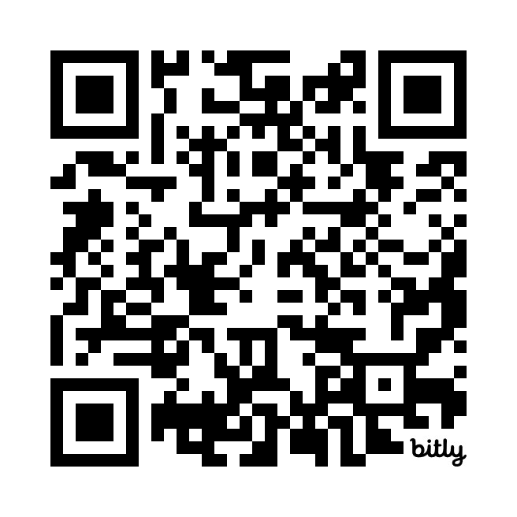

Before submitting the billing and/or claims please complete

the Vendor Invoice Form (CO-17) supplied by the

CT DPH TB Control Program and found here:  <https://bit.ly/tbvinvoice>

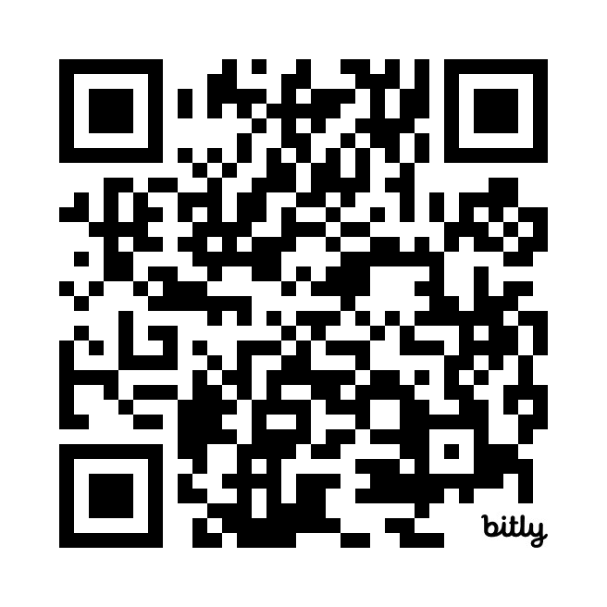

Instructions for completing Form CO-17 may be found here: <https://bit.ly/tbvinst>

If you need further information, please call Yvette Mateo at the CT DPH TB Control Program at 860-509-7698.

**Patient Information**

Please take this letter with you and visit the lab Facility below for TB testing:

**Quest Diagnostics - See Attached List Provided by Town**

Patient Name:______________________________ DOB:______________________

Address:______________________________________________________________

Phone:_______________________________________________________________

**Screening Test - IGRA**

□ This patient needs an Interferon-Gamma Release Assay (IGRA) test (e.g., QuantiFERON) and is hereby referred for an IGRA test.  – OR -

□ This patient needs a Mantoux tuberculin skin test (TST) and is hereby referred for a TST.

 Diagnosis Code: Z11.1

**Copy to: (Insert LHD and contact info)

**Referring Local Health Department /District Information**

**Health Department/District Medical Adviser/Director:**

______________________________ _______________

Signature Date

**Appendix D:**

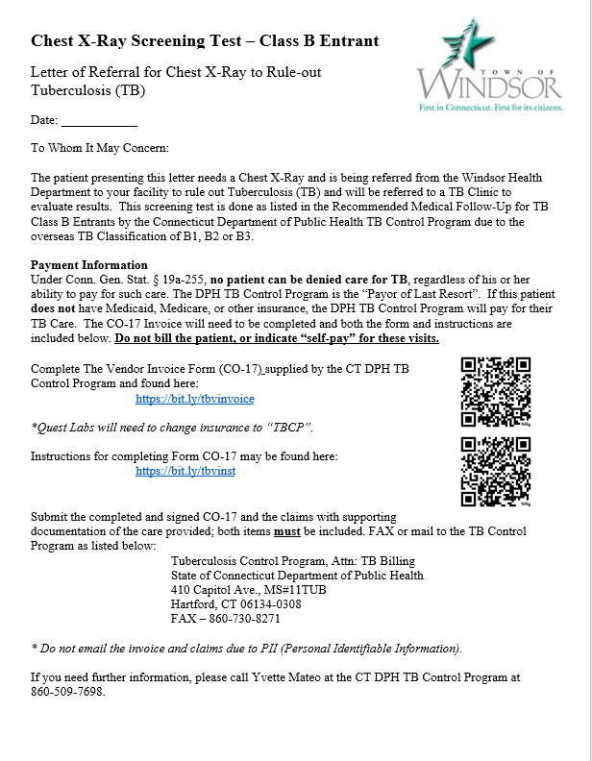

**Appendix E**

