






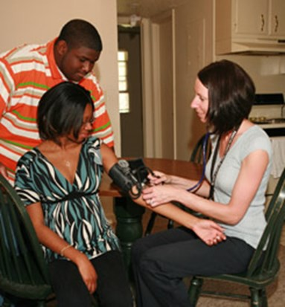

YOUR LOGO HERE
Your Call to action:
Join CAPHN today!
- Simply fill out the form below
Name: Job Title: Agency: Preferred Mailing Address:
Street City: State: Zip: - (Plus4) Phone: ( ) Email:
I am renewing my membership
You may share my information with other professional organizations
Membership Categories and Dues
Membership Fees: $50 Regular $40 Associate
$20 Undergrad Nursing Student I would like to serve on one or more of the committees described on the back
FINANCE MEMBERSHIP PRACTICE PROGRAM
AD HOC
- Send in completed membership form with a check payable to: CNA (CT Nurses Association)
[PLEASE ADD — CAPHN - to the memo line]
515 Centerpoint Drive
Middletown, CT 06457
INSIDE:
Learn about CAPHN &
Membership Form
CAPHN
EXPERTS IN
PUBLIC HEALTH NURSING

CAPHN
CAPHN c/o CNA
515 CenterPoint Drive
Middletown, CT
06457

www.CTAPHN.org

CAPHN COMMITTEES

WHERE DO YOU SEE YOURSELF?




OUR PURPOSE
To provide expertise in public health
through leadership, advocacy, education, collaboration and nursing practice.
OUR MISSION
To enhance the health and wellness of communities through public health
nursing practice.
- We are Registered Nurses engaged in public health nursing practice,
Education, and policy

- We are individuals and organizations
with an interest in public health nursing

- CAPHN was founded in 2002 with support of the CT Nurses Association (CNA) and the Massachusetts
Association of Public Health Nurses
(MAPHN).
WHO IS CAPHN
CAPHN MEMBERSHIP BENEFITS
- Professional development and education
- Information dissemination
- Networking opportunities
- Public Health Nursing (PHN) advocacy

PUBLIC HEALTH NURSES

- Advocate
- Collaborate
- Communicate
- Consult
- Investigate
- Link
- Organize
- Promote
- Sponsor
- Educate

WHO ARE PUBLIC HEALTH NURSES?

- PHN’s improve and protect the health of the community through public health nursing practice
- PHN’s are employed in local and state health departments /districts, schools, visiting nurse agencies , occupational health settings, faith communities, and any place where population/ community-based care is focused.
FINANCE COMMITTEE
Develops the annual budget, monitors the fiscal affairs of the association and recommends fiscal policy to the Board of Directors
MEMBERSHIP COMMITTEE
Responsible for attracting new CAPHN members while retaining current ones as well as marketing the association
PRACTICE COMMITTEE
Works with the CAPHN Board to support public health practice in CT and recommends policy changes as appropriate
PROGRAM COMMITTEE
Responsible for the development and provision of educational programs for the CAPHN membership
AD HOC COMMITTEES
Appointed by the president for short-term projects not assigned to a standing committee

CAPHN MEMBERSHIPS
REGULAR MEMBERSHIP
Registered Nurse currently or formerly engaged in public health nursing practice, education or policy
ASSOCIATE MEMBERSHIP
An individual or organization
with an interest in public health in Connecticut
STUDENT MEMBERSHIP
An individual who is matriculated into an undergraduate nursing program

